Phase 1

11-07-2022

Day 1

Html, css, js, react js ----🡪 React Native

Android

Angular Ionic framework

Day 2 : 12-07-2022

Day 3 : 13-07-2022

Git is a open source sub version control tool which help to record or track the flow of application Or project. It is use to share the code for one team to another team.

3 types of sub version control tool we can use

1. Local version control : RCS Revision control System
2. Central Version Control : SVN : Server and Client. In this version control we get only Remote repository (Remote location folder. Whey client to that repository). They push and pull.
3. Distributed Sub Version control : Git : In this type of tool we get local as well as remote repository.

Git is a distribution sub version control which provided a features local repository which help to connect remote repository ie GitHub, GitLab, AWS, Azure or any cloud remote repository.

Open the git terminal

git --version

git init : This command is use to make the folder as local repository

This command you have to execute only one time.

git status : this command is use to check the current status of local repository

This command execute again and again to check the current status of local repository.

git add filename :This command is use to move the file from local file system to staging area.

Or

git add . : this command is use to add more than one file or folder present in current location.

git commit –m “message1” This command is use to move file or folder from staging area to local repository.

14-07-2022 : Day 4

git branch : git branch is like a pointer which hold more than one commit details.

Git provide by default one branch and the name of the branch may be master or main.

git branch : This command is use to display all branches present in current folder.

git branch branchName : This command is use to create the branch

git checkout branchName : This command is use to move or switch from one branch to anther branch.

Or

git checkout –b branchName : This command is use to create the new branch and switch to that banch.

git merge branchName: This command is use to merge user-defined branch code to current rnach

git branch –D branchName : This command is use to delete the branch

git checkout –b branchname

remote repository

git hub, gitlab, any cloud vendor

please create own git hub account with your personal email id

git branch –m branchName : This command is use to rename the branch

git remote add origin URL This command is use to connect your local repository with remote repository. This command only once.

git push –u origin main This command is use to push the local repository code to remote.

git clone URL : it is use to download remote repository in local machine.

git pull : this command is use to get new update contents from remote repository to existing repository in local machine.

Java : Java is a platform independent and pure object oriented programming language.

Initial name of Java is Oak.

They rename to Java in Nov 1995.

Java developed by Games Josling and team.

It was part of sun micro system and belong to Oracle.

Version of Java

1. 18 version

Day 5:

18-07-2022

object : object is any real world entity. Object is a concept.

Properties or state-🡪 have -🡪 name,age, height, color etc 🡪 variables or fields etc.

Person

Behavior -🡪do/does -🡪 teaching, sleeping, talking, typing etc 🡪 functions or methods.

Bank

Animal

Wheel, price, color etc

Car

Start, appliedGear, moving, stop etc

Employee

Etc

class : blue print of object or template of object or it user-defined data types which is use to describe the object.

syntax of the class

class ClassName {

fields or variable

methods or functions

}

Pre-defined method ie main method and this method must be part of class.

Class name must be follow pascal naming rules.

If class contains one word first letter of class start with upper case like Demo, Test, Employee

If class contains more than one word each word first letter upper case, EmployeeDetails, ManagerInfo etc.

class Demo {

public static void main(String args[]) {

System.out.println(“Welcome to Java”);

}

}

We have to save the program with className.java

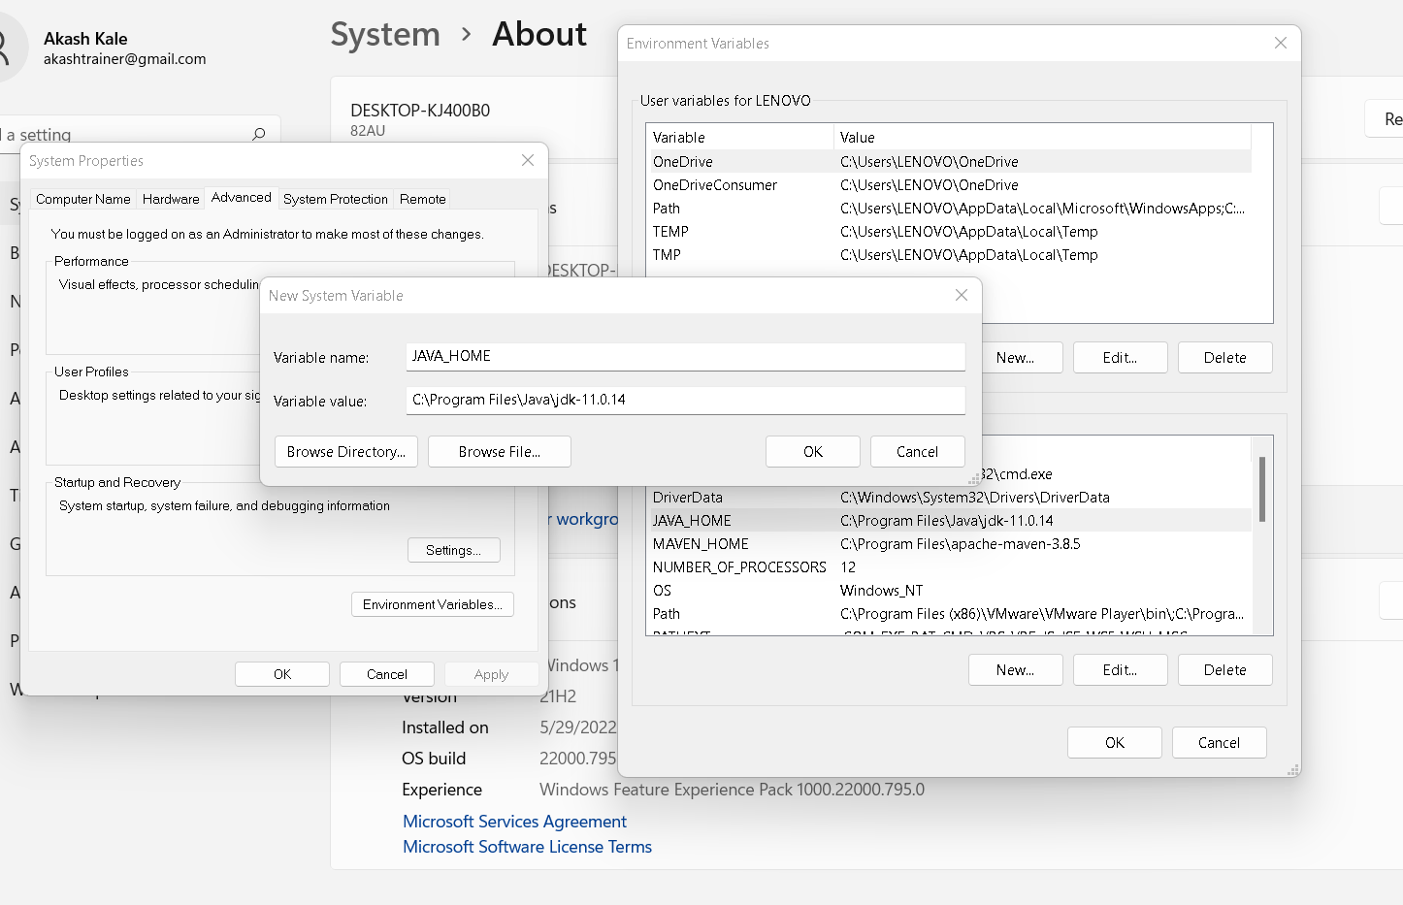

Path

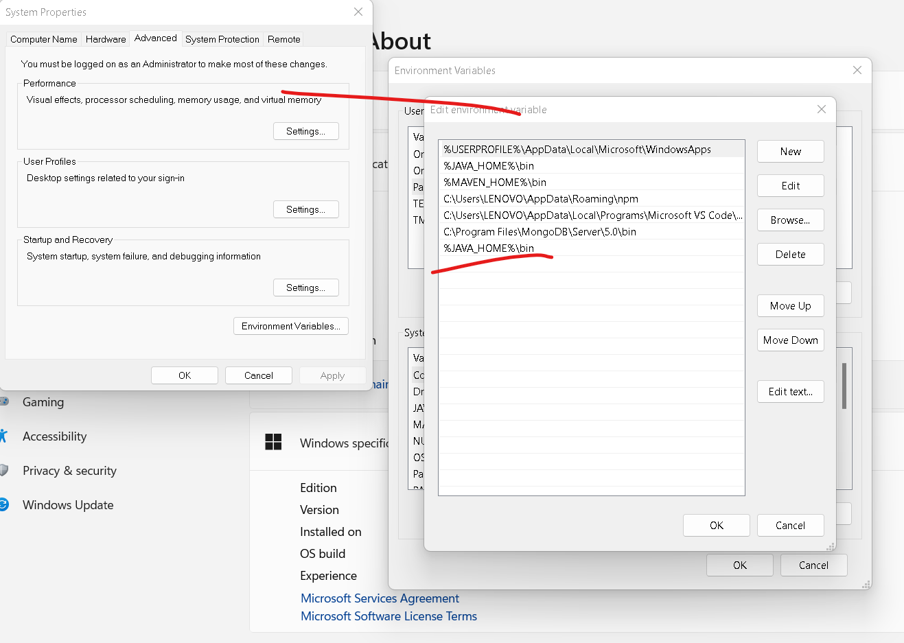

javac Demo.java : it is use to compile the program

java Demo : it is use to run the program

Demo.java

class Demo {

public static void main(String args[]) {

System.out.println("Welcome to Java ");

System.out.println("Welcome to Java once again");

System.out.print("Welcome again");

System.out.printf("Welcome to Java again\n");

}

}

Data types

It is a type of data which tells what type of data it can hold.

2 types of data types

1. Primitive data types : it is use to store only value

8 types of primitive data types

1. byte 1 byte
2. short 2 byte
3. int 4 byte
4. long : it is use to store the value without decimal. 8 byte
5. float 4 byte
6. double : it is use to store the value with decimal 8 byte
7. char : any single character 2 byte
8. boolean : true or false 1 bit

1. Non primitive data type or reference data type : it is use to store the value as well as reference of another data types.

class Demo {

public static void main(String args[]) {

int a;

int b=10;

System.out.println(b);

System.out.println("value of b is "+b);

System.out.printf("value of b is = %d\n",b);

}

}

Type casting : converting one data type to another data type is known as type casting.

2 types

1. Implicit type casting :
2. Explicit type casting :

Int family

--------🡪 implicit type casting -----🡪

byte short int long

🡨-- explicit type casting --------------

Implicit type casting

int float

Explicit type casting

Type casting example

class Demo {

public static void main(String args[]) {

/*byte a=10;

short b=a; //implicit type casting

System.out.println(a);

System.out.println(b);

short c=10;

byte d =(byte)c; // explicit type casting

System.out.println(c);

System.out.println(d);*/

//float x = 100.10; // error

//float x = (float)100.10;

//float x = 100.10f;

//double x = 100.10;

float x = 100.10f;

int y = (int)x; // explicit type casting

System.out.println(x);

System.out.println(y);

}

}

Operator

1. Arithmetic operator
2. Logical operator
3. Assignment operator
4. Conditional operator
5. Increment and decrement operator
6. Ternary operator

If statement

1. Simple if
2. If else
3. If else if
4. Switch statement : it I use to execute set of statement base upon user or programmer decision.

Syntax

switch(label) {

case v1: block1;

break;

case v2: block2;

break;

case v3: block3;

break;

default : wrongblock

break;

}

switch, case, break and default are keywords.

Switch statement program

class Demo {

public static void main(String args[]) {

int choice =10;

switch(choice) {

case 1:System.out.println("block1");

break;

case 2:System.out.println("block2");

break;

case 3:System.out.println("block3");

break;

default : System.out.println("Wrong choice");

break;

}

System.out.println("finish");

}

}

Taking the value through keyword in java

1. Using Scanner class.
2. Using DataInputStream class
3. BufferedReader class
4. Command line interface

Scanner : it is a pre defined class part of util package. Package is a collection of classes and interface.

Syntax to create the Scanner class object.

Scanner obj =new Scanner(System.in);

obj.nextInt();

obj.nextFloat();

obj.nextBoolean();

obj.next(); it is use to receive the string value. It is use to take only one word

obj.nextLine(); : it is use to take more than one word

looping

it is use to execute the task again and again till the condition become false.

while loop

do while loop

for loop

for each loop or enhanced loop : this type of loop we will use with array or collection of classes.

Non primitive or reference data type

1. array
2. class (it may be pre-defined or user-defined class)
3. interface (it may be pre-defined or user-defined)
4. enum

array : array is use to store more than value of same types.

Syntax

datatype arrayName[];

int abc[];

int a;

syntax of for each loop

for(datatype variableName: arrayName) {

}

Array declaration with initialization and display the value using for loop as well as for each loop

class Demo {

public static void main(String args[]) {

//int abc[10]; //valid in C or C++ but not in java

int abc[]; // valid in java

int xyz[]={10,20,30,40,50,60,100,200,140,670,80,90};

System.out.println("Value of 0 index position "+xyz[0]);

System.out.println("Value of 1 index position "+xyz[1]);

System.out.println("Size of the array is "+xyz.length);

System.out.println("Retrieve the value using for loop");

for(int i=4;i<xyz.length;i++) {

System.out.println(xyz[i]);

}

System.out.println("Retrieve the value using for each loop");

for(int n : xyz) {

System.out.println(n);

}

}

}

Memory creation of array

Syntax

datatype arrayName[]=new datatype[size];

int abc[]=new int[10]; here abc can hold 10 value of type int.

float xyz[]=new float[100]; here xyz can hold 100 value of type float.

String : In java String is a pre-defined class part of lang package. It is also known as reference data types. By default every java program import lang package.

Combination of more than one character enclosed in double quotes.

Syntax to create the String class object.

String str1 = “Welcome to Java Training”; // literal style

String str2 = new String(“Welcome to Java Training”); // creating using new keyword.

String class methods

import java.util.*;

class Demo {

public static void main(String args[]) {

String str1 = "Welcome to Java Training";

String str2 = new String("Welcome to Java Training");

System.out.println(str1);

System.out.println(str2);

System.out.println(str1.length());

System.out.println(str2.length());

System.out.println(str2.toUpperCase());

System.out.println(str2.toLowerCase());

System.out.println(str2.substring(2));

System.out.println(str2.substring(2,10));

System.out.println(str2.indexOf('a'));

System.out.println(str2.lastIndexOf('a'));

}

}

==

It will check the value as well as reference code or hashcode.

.equals()

It will check only value doesn’t matter it may be same memory or different memory.

Example

import java.util.*;

class Demo {

public static void main(String args[]) {

String name1 = "Raj Deep";

String name2 = "Raj Deep";

String name3 = new String("Raj Deep");

String name4 = new String("Raj Deep");

if(name3==name4) {

System.out.println("Equal");

}else {

System.out.println("Not Equal");

}

if(name3.equals(name4)) {

System.out.println("Equal");

}else {

System.out.println("Not Equal");

}

}

}

Day 6:

19-07-2022

object and class

object : is any real world entity

class : blue print of object or template of object.

Car

Simple example of user defined object

class Car {

int wheel;

float price;

String color;

void start() {

System.out.println("Car Start");

}

void appliedGear() {

System.out.println("Applied Gear");

}

void moving() {

System.out.println("Car is moving");

}

void stop() {

System.out.println("Car Stop");

}

}

class App {

public static void main(String args[]) {

System.out.println("Main method");

//start();

Car innova = new Car();

innova.start();

innova.stop();

}

}

Types of fields or variables

3 types

1. instance variable
   1. The variable which declared inside a class but outside method including main method is known as instance variable.
   2. Instance variable hold default value according to their data types. Like int family 0, float family 0.0, char space, boolen false, String null.
   3. We can access all instance variable inside a all methods but method must be non static and it must be part of same class.
2. local variable
   1. The variable which declared inside a method is known as local variable.
   2. Local variable doesn’t hold default value we have to initialize while using that variable.
   3. The scope of the variable within that method where it declared.
3. static variable : we will see that concept later on

instance variable and local variable example

class Car {

int wheel;

float price;

String color;

void start() {

int temp=100;

System.out.println("Car Start");

System.out.println("Wheel "+wheel);

System.out.println("Price "+price);

System.out.println("Color "+color);

System.out.println("temp "+temp);

}

void appliedGear() {

System.out.println("Applied Gear");

}

void moving() {

System.out.println("Car is moving");

}

void stop() {

String msg="Welcome";

System.out.println("Car Stop");

System.out.println("Wheel "+wheel);

System.out.println("Price "+price);

System.out.println("Color "+color);

System.out.println("msg "+msg);

}

}

class App {

public static void main(String args[]) {

System.out.println("Main method");

//start();

Car innova = new Car();

innova.start();

innova.stop();

}

}

Creating more than one object and set the value for instance variable from main method

class Car {

int wheel;

float price;

String color;

void displayCarInfo() {

System.out.println("Wheel "+wheel);

System.out.println("Price "+price);

System.out.println("Color "+color);

}

}

class App {

int b;

public static void main(String args[]) {

int a;

Car innova = new Car();

innova.displayCarInfo();

innova.wheel = 4;

innova.color="Gray";

innova.price = 1800000;

innova.displayCarInfo();

Car ertiga = new Car();

ertiga.displayCarInfo();

ertiga.wheel = 4;

ertiga.color = "White";

ertiga.price = 1200000;

ertiga.displayCarInfo();

}

}

Constructor : it is a type of special method which help to create the object.

Pts

1. Constructor have same name as class itself.
2. Constructor doesn’t contains return type not even void also.
3. Constructor no need to call it will call automatically when we create the object.

Simple example of constructor

class Car {

Car() {

System.out.println("Object created...");

}

void displayCarInfo() {

System.out.println("Car Details");

}

}

class App {

public static void main(String args[]) {

Car innova = new Car();

innova.displayCarInfo();

}

}

Method, empty constructor and parameterized constructor

class Operation {

int a,b,sum;

Operation() {

a=10;

b=20;

}

Operation(int x, int y){

a=x;

b=y;

}

void setValue(int x, int y) {

a=x;

b=y;

}

void add() {

sum = a+b;

}

void display() {

System.out.println("sum is "+sum);

}

}

class App {

public static void main(String args[]) {

Operation op1 = new Operation(); op1.display();

Operation op2 = new Operation(); op2.add(); op2.display();

Operation op3 = new Operation(); op3.setValue(100,200); op3.add(); op3.display();

Operation op4 = new Operation(11,22); op4.add(); op4.display();

Operation op5 = new Operation();

op5.setValue(1,2);

op5.setValue(3,4);

op5.setValue(5,6);

op5.add();

op5.setValue(7,8);

op5.display();

Operation op6 = new Operation(100,200);

op6.setValue(2,3);

op6.add();

op6.display();

}

}

In the life of the object if we want to perform any task only one time then we have to use empty parameter constructor. If we want to perform the task more than one time that type of task we have to do inside a method.

Encapsulation : Binding or wrapping data (fields or variables) and code (method or function ) in a single unit is known as encapsulation.

Class :

If instance variable and local variable have same name then local variable hide the visibility of instance variable. To refer to instance variable we have to use this keyword. This keyword is use to refer the current object.

this.instancevariableName

Example

class Employee {

private int id;

private String name;

private float salary;

/*public void setValue(int id1, String name1, float salary1) {

id = id1;

name = name1;

//salary = salary1;

if(salary1 < 0) {

salary = 8000;

}else {

salary = salary1;

}

}*/

public void setValue(int id, String name, float salary) {

this.id = id;

this.name = name;

//this.salary = salary;

if(salary < 0) {

this.salary = 8000;

}else {

this.salary = salary;

}

}

void displayEmpInfo() {

System.out.println(" id "+id);

System.out.println(" name "+name);

System.out.println(" salary "+salary);

}

}

class App {

public static void main(String args[]) {

Employee emp1 = new Employee();

//emp1.id =100;

//emp1.name="Ravi Kumar";

//emp1.salary = -12000;

emp1.setValue(100,"Ravi Kumar",-12000);

emp1.displayEmpInfo();

}

}

Inheritance : Inheritance is use to inherits the properties and behavior of old class to new class.

class OldClass { super class or base class or parent class

properties

behavior

}

class NewClass extends OldClass{ sub class or derived class or child class

properties

behavior

}

class A {

void dis1() {

System.out.println("A class method");

}

}

class B extends A{

void dis2() {

System.out.println("B class method");

}

}

class App {

public static void main(String args[]) {

A obj1 = new A();

obj1.dis1();

B obj2 = new B();

obj2.dis2();

obj2.dis1();

}

}

Types of inheritance

1. Single inheritance : One super class and one sub class

class A { }

class B extends A { }

1. Multilevel inheritance

One super class and n number of sub class connected one by one

class A { }

class B extends A{ }

class C extends B { }

class D extends C { }

1. Hierarchical inheritance

One super class and n number of sub class connected to super class

class A { }

class B extends A { }

class C extends A{ }

class D extends A{ }

1. Multiple inheritance

More than one super class and one sub class

class A { }

class B { }

class C extends A, B { } : Java doesn’t support this type of inheritance . this type of inheritance java support indirectly using interface.

OOPs relationship

Is a relationship

Has a relationship

Manager is a Employee

Developer is a Employee

Employee has a Address

class Employee {

id,name,salary // primitive property

}

class Manager extends Employee {

numbeOfEmp

Address add = new Address();

}

class Developer extends Employee{

projectName

}

class ProjectManager extends Manager {

typeOfProject

}

class Address {

city, state

}

Has relationship

1. Association
2. Aggregation
3. Composition

Association : if we want to achieve has a relationship we have to create the object of one class in another class

class A {

B obj1 = new B(); zero or 1 or many

}

class B {

A obj1 = new A(); zero or 1 or many

}

Aggregation : aggregation is a type of association but known as weak association.

class Employee {

Address add = new Address(); zero or 1 or many

}

class Address {

Employee emp = new Employee() not good relationship

}

Composition :composition is a type of association but known as strong association.

class Student {

StudentHistory sh = new StudentHistory();

}

class StudentHistory {

}

Is a and has a relationship example

import java.util.*;

class Employee {

private int id;

private String name;

private float salary;

Scanner sc = new Scanner(System.in);

Address add = new Address();

public void readEmp() {

System.out.println("Enter the id");

id = sc.nextInt();

System.out.println("Enter the name");

name = sc.next();

System.out.println("Enter the salary");

salary = sc.nextFloat();

}

public void disEmp() {

System.out.println("id is "+id);

System.out.println("name is "+name);

System.out.println("salary is "+salary);

}

}

class Manager extends Employee {

int numberOfEmp;

public void readMgr() {

readEmp();

System.out.println("Enter the number of employee working under him");

numberOfEmp = sc.nextInt();

add.readAdd();

}

public void disMgr() {

disEmp();

System.out.println("Number of emp working "+numberOfEmp);

add.disAdd();

}

}

class Address {

private String city;

private String state;

Scanner ss = new Scanner(System.in);

public void readAdd() {

System.out.println("Enter the city");

city = ss.next();

System.out.println("Enter the state");

state = ss.next();

}

public void disAdd() {

System.out.println("city is "+city);

System.out.println("state is "+state);

}

}

class App {

public static void main(String args[]) {

Manager mgr = new Manager();

//mgr.readEmp();

mgr.readMgr();

//mgr.disEmp();

mgr.disMgr();

}

}

20-07-2022

package com;

class Employee {

int id;

String name;

float salary;

public Employee() {

id=123;

name="Unknown";

salary = 8000;

}

Employee(int id, String name, float salary){

this.id = id;

this.name=name;

this.salary = salary;

}

void display() {

System.out.println("id is "+id);

System.out.println("name is "+name);

System.out.println("salary is "+salary);

}

}

public class ConstructorExample {

public static void main(String[] args) {

Employee emp1 = new Employee(); emp1.display();

Employee emp2 = new Employee(100, "Ravi", 14000); emp2.display();

}

}

Polymorphism : one name many forms or implementation.

2 types of polymorphism

1. Compile time : static binding or early binding : method overloading

The method have same name and same method signature but different parameter list (type of parameter list or number of parameter list). We can achieve method overloading in same class or different class.

public void area(int r) {

double area = 3.142*r*r;

}

public void area(int b, int h) {

double area = 0.5*b*h;

}

1. Run time : dynamic binding or late binding : method overriding

The method have same name and same method signature ie number of parameter list, type of parameter list and return type must be same.

To achieve method overriding we require inheritance concept mandatory.

Run time polymorphism example

**package** com;

**class** Bike {

**public** **void** speed() {

System.***out***.println("60km/hr");

}

}

**class** Honda **extends** Bike {

**public** **void** color() {

System.***out***.println("Black");

}

}

**class** Pulsar **extends** Bike {

**public** **void** speed() {

System.***out***.println("90km/hr");

}

**public** **void** color() {

System.***out***.println("Red");

}

}

**class** Tvs **extends** Bike {

**public** **void** color() {

System.***out***.println("Gray");

}

**public** **void** speed() {

**super**.speed(); // calling super class speed method

System.***out***.println("20km/hr");

}

}

**public** **class** RuntimePolymoprhism {

**public** **static** **void** main(String[] args) {

Honda hh = **new** Honda(); hh.color(); hh.speed(); // 60 km/hr

Pulsar pu = **new** Pulsar(); pu.color(); pu.speed(); // 90 km/hr

Tvs tvs = **new** Tvs(); tvs.color(); tvs.speed(); // 60 km/hr 20 km/hr

}

}

abstract, final and static keywords

abstract keyword :

1. Abstract keyword we can use with class and method but not with variable.
2. Abstract method is known as the method without body or without curly braces or incomplete method.

abstract returnType methodName(parameterList);

abstract void speed();

1. If class contains one or more abstract we have to declare that class as abstract class.

abstract class className {

}

1. Whichever class extends abstract class that class must be provide the body for all abstract method belong to that class. That class can ignore only if that class itself is a abstract class.
2. We can’t create the object of abstract class.
3. Abstract class can contains normal as well as abstract method ie it can contains zero or 1 or many abstract method.

Abstract keyword example

**package** com;

**abstract** **class** Bike {

**abstract** **void** speed();

**void** mailage() {

System.***out***.println("55km/hr");

}

}

**class** Honda **extends** Bike {

**void** color() {

System.***out***.println("Black");

}

**void** speed() {

System.***out***.println("50km/hr");

}

}

**public** **class** AbstractExample {

**public** **static** **void** main(String[] args) {

//Bike bb = new Bike();

Honda hh = **new** Honda();

hh.speed();

hh.color();

hh.mailage();

}

}

Final keyword

1. Final keyword we can use with variable, method and class.
2. Final variable : to declare a constant variable in java we use final keyword. We can’t change the value of final variable
3. Final method : if method is final we can’t override that method in sub class but we can use it.
4. Final class : if class is final we can’t extends or inherits that class.

Static keyword

1. Static keyword we can use with variable and method but not with class. (if class is inner class then we can use static keyword but not with outer class).
2. Static variable : if variable is static we can assign the value for that variable with help of class name.
3. Static method : if method is static we can call that method with help of class name.
4. We can assign the value of static variable even through object also as well as we can call static method with help of object also.
5. Inside a non static method we can access static as well as non static variable directly
6. Inside static method we can access only static variable directly we can’t access non static variable directly we have to create the object of that class.

Static example

**package** com;

**class** Abc {

**int** a; // non static variable

**static** **int** *b*; // static variable

**void** dis1() {

System.***out***.println("Non static method");

System.***out***.println("a "+a);

System.***out***.println("b "+*b*);

}

**static** **void** dis2() {

System.***out***.println("Static method");

Abc obj = **new** Abc();

System.***out***.println("a "+obj.a);

System.***out***.println("b "+*b*);

}

}

**public** **class** StaticExample {

**public** **static** **void** main(String[] args) {

Abc obj1 = **new** Abc();

obj1.a=10;

Abc.*b*=20;

obj1.*b*=30;

obj1.dis1();

Abc.*dis2*();

obj1.*dis2*();

}

}